Assessment Schedule – 2013
Mathematics with Statistics: Apply algebraic methods in solving problems (91261)
Evidence Statement
ONE | Expected Coverage |  |  | Achievement | Merit | Excellence
(a)(i) | (2x – 5) (3x + 2)  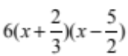 |  |  | Correctly factorised.  Correct decimal / rounding.
(a)(ii) | 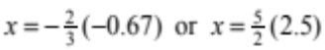 |  |  | Complete correct solutions found.  Any rounding / truncation.  Consistency with a(i) but not trivial (coefficients of x > 1)
(b) | b² – 4ac = 0  16m = 64  m = 4 |  | Perfect square.  4(x – 1)(x – 1) = 0 or equivalent  x = 1  m = 4 | Recognising the discriminant must = 0.  OR  CRO. | Calculating the value of m.
(c) | 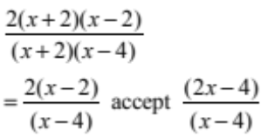 |  |  | Factorised.  OR  Factorised and simplified with one error in factorising. | Correctly simplified.
(d) | a² – 3 a – 4 = 0  (a – 4)( a + 1) = 0  a = 4 or a = –1  √(x + 2) = 4 or  √( x + 2) = –1 (not a solution)  x = 14 | ((x+2) – 4)²  = (3√(x + 2))²  x² – 4x + 4 = 9(x + 2)  x² – 13x – 14 = 0  (x + 1)(x – 14) = 0  x = –1 and x = 14 |  | Equation rearranged and factorised  OR  Solved using either method.  (RANW= n) | Solved for x.  x = 14 and –1 but not disregarding  x = 0. | Recognition that x = –1 is not a solution.
(e)(i)  (ii) | x² – mx + nx – mn = 2(x² – nx + mx – mn)  x² + 3mx –3nx – mn = 0  x² + (3m – 3n)x – mn = 0  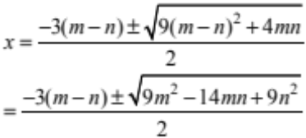  Hence 9m² – 14mn + 9n² > 0  OR 9(m – n)² + 4mn > 0 |  |  | Cross multiplication and collection of like terms.  Mei for one incorrect simplification step. | Correct substitution into the quadratic formula, not necessarily simplified.  OR  No roots given but correct inequality in (ii). | Roots and inequality found.

NØ no response; no relevant evidence
N1 attempt at one question
N2 1 of u
A3 2 of u
A4 3 of u
M5 1 of r
M6 2 of r
E7 1 of t
E8 2 of t

TWO | Expected Coverage | Achievement | Merit | Excellence
(a) | 64a⁶/64a¹⁰  = 1/ a⁴ (or a^{–4}) | Correct simplification.
(b)(i) | 2x^{0.5} ( or 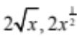 | Correct simplification.
(ii) | 2x^{0.5} × 3x^{1.5} = 6x² | Correct simplification.  Consistent with (b) (i).
(c) | 6x² + 12x – 48 = 0  x² + 2x – 8 = 0  (x + 4) (x – 2) = 0  x = –4 and x = 2 | Correct equation = 0  OR  CAO or guess and check.  OR  If answer correct & x = –4 is eliminated. | Equation solved showing equation.
(d) | 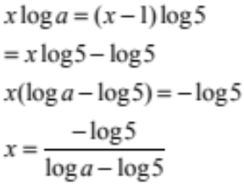 |  | Expression written in log form and expanded. | Expression for x correct.  OR equivalent.
(e) | (3x + n)(x – 2) = 0  3x² + (n – 6)x – 2n =0  n – 6 = 4  n =10  (3x + n) =0  root is –n / 3 = –10 / 3  k = 2n = 20 | Establishing the relationship.  OR  CRO of k and other root. | One value for n or k or the other root found with algebraic working. | Solutions found for k and the other root with algebraic working.
NØ no response; no relevant evidence
N1 attempt at one question
N2 1 of u
A3 2 of u
A4 3 of u
M5 1 of r
M6 2 of r
E7 1 of t
E8 2 of t

THREE | Expected Coverage |  | Achievement | Merit | Excellence
(a)(i) | x³ = 64  x = 4 |  | Correctly solved.
(ii) | 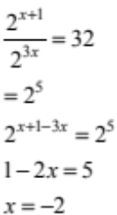 |  | CRO  OR  Whole equation in powers of two.  OR  Use of log, with exponents eliminated.  eg: (x + 1)log2  = log32 +x log8 | Correctly solved.
(b)(i) | 1800 × 0.6^{n} |  | Expression correct.
(ii) | 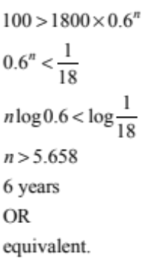 |  | In/Equation rearranged in index form.  OR  CRO.  OR  Solved by guess and check.  OR  5.7 years with working.  OR  Consistent use of 0.4^{n} give n = 3.15 | Number of years found as a whole number  (n = 6)  Consistent use of 0.4^{n} using logs give n = 4 years (whole number).
(c) | 9x² + 6x + 8 = 0  b² – 4ac = –252  therefore no real roots.  Graph of the parabola does not cut the x-axis. | A squared term can never be negative hence there is no solution therefore the graphs do not intersect each other. | Quadratic expression rearranged=0  OR  Explanation of no x intercepts because the discriminant is less than zero, without –252.  OR  A squared term can never be negative hence there is no solution. | Discriminant found and therefore no real roots but no x axis analysis.  OR  Quadratic expression rearranged = 0.  AND  Explanation of no x intercepts because the discriminant is less than zero, without –252. | Discriminant calculated and explanation of no x intercepts given.  OR  Full explanation of the two graphs not intersecting.
(d) | x = (mx)²  x(m²x – 1) = 0  therefore either  m² x = 1  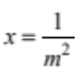 if x ≠ 0.  OR x = 0  But log 0 is undefined  Therefore |  | Equation given in index form. | One solution found.  OR  Both solutions and x = 0 not disregarded. | Correctly solved with  x = 0 disregarded.  OR  Use of log properties to solve completely. X = 0 still needs to be disregarded.

NØ no response; no relevant evidence
N1 attempt at one question
N2 1 of u
A3 2 of u
A4 3 of u
M5 1 of r
M6 2 of r
E7 1 of t
E8 2 of t

Judgement Statement
 | Not Achieved | Achievement | Achievement  with Merit | Achievement  with Excellence
Score range | 0 – 6 | 7 – 13 | 14 – 18 | 19 – 24

